1. 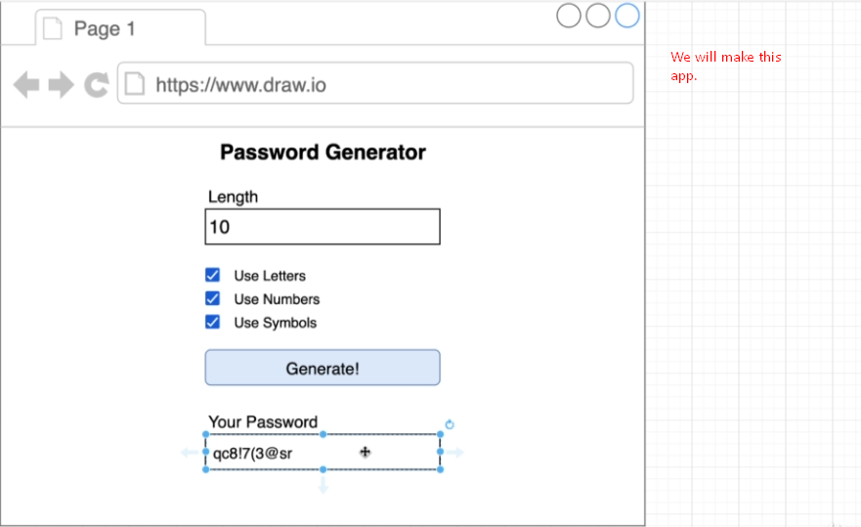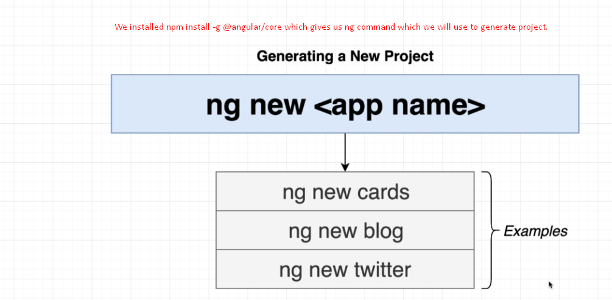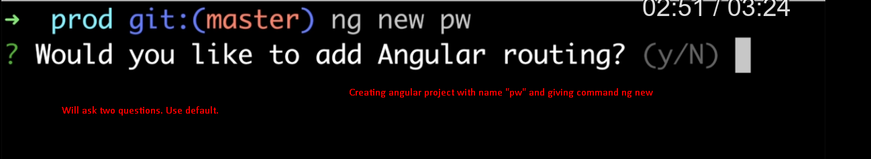  
   The above command would do the followings
   1. Generate a new angular project with name “pw” which is a running/working project.
   2. Would create application skeleton with some default files.
   3. Would install some dependencies.
2. 